Reducing Code with Custom Auto Configurations –

<https://github.com/dustinschultz/just-gif-it>

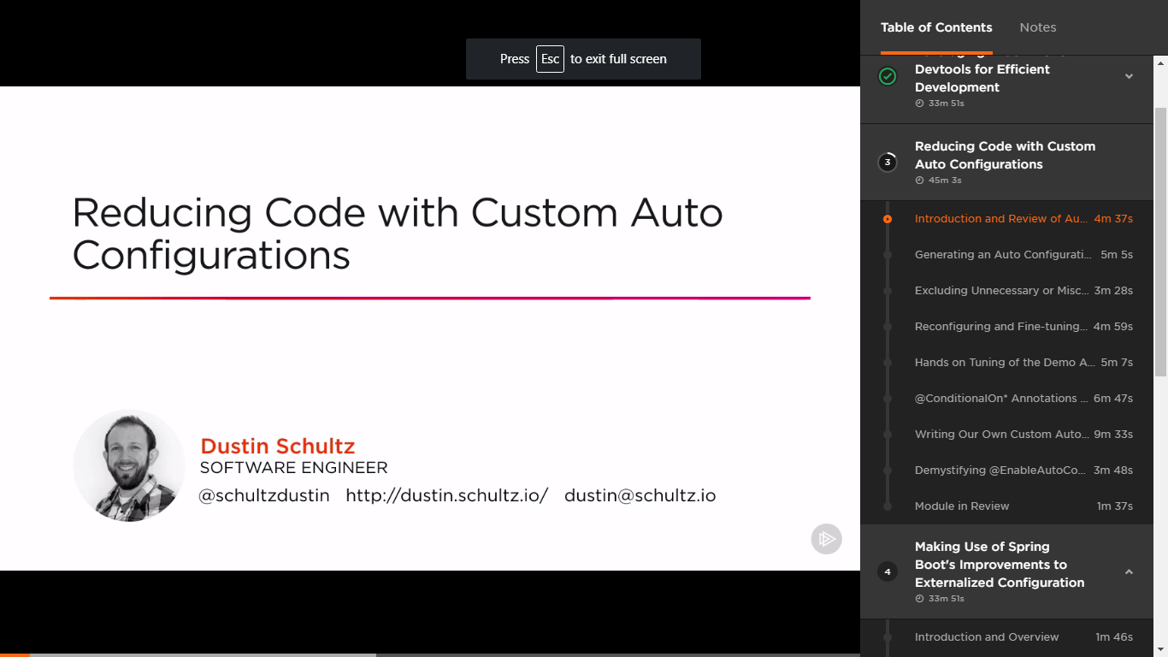

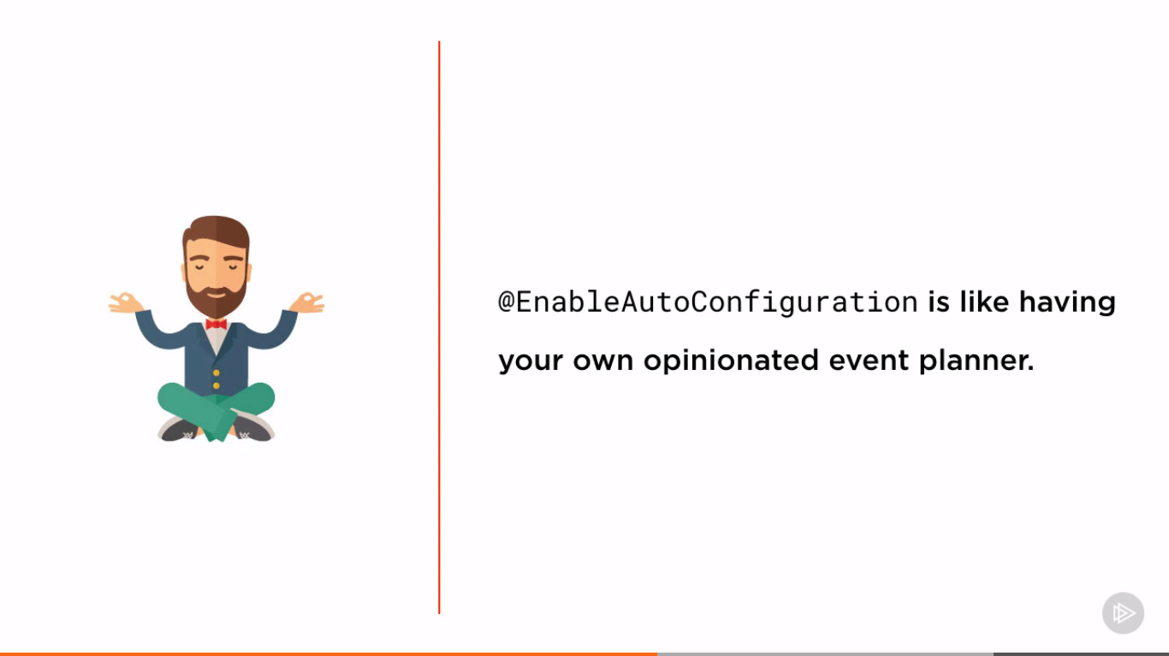

By Phill Webb – Co leader of SB

Spring framework – is like ingredients required to prepare a cake

Spring boot – fully baked cake

@EnableAutoConfiguration – Baker with a recipe who knows how to make an undecorated cake with ingredients

Custom Application is like frosting and other stuff to decorate it.

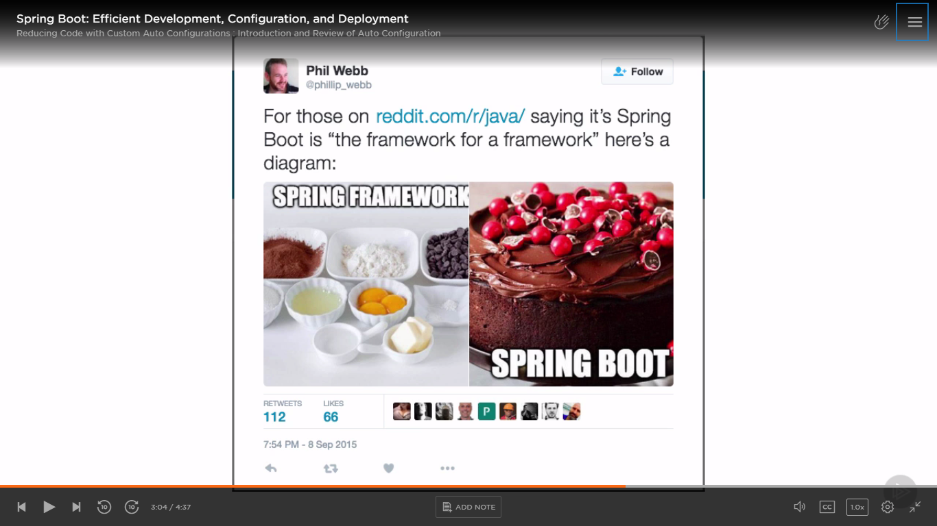

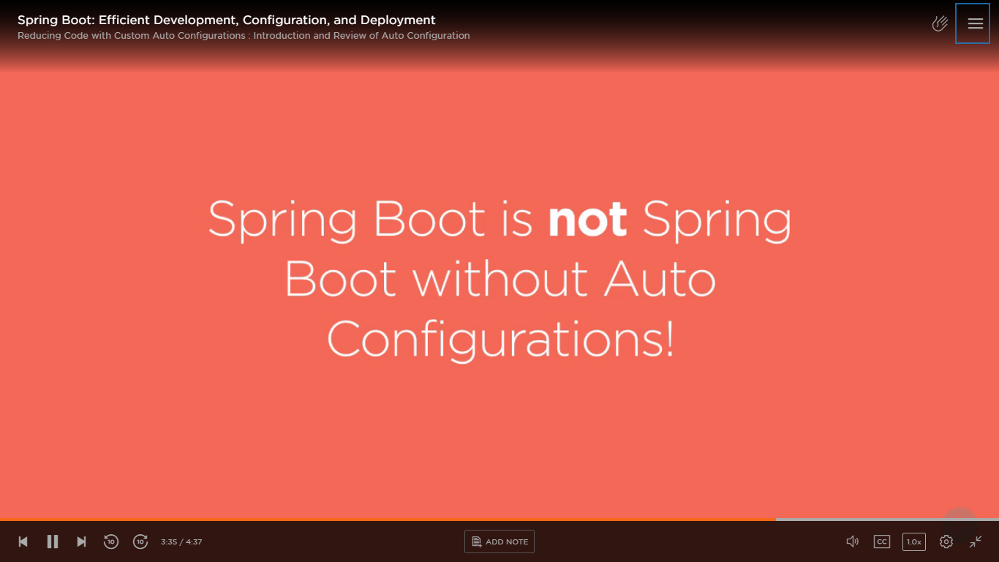

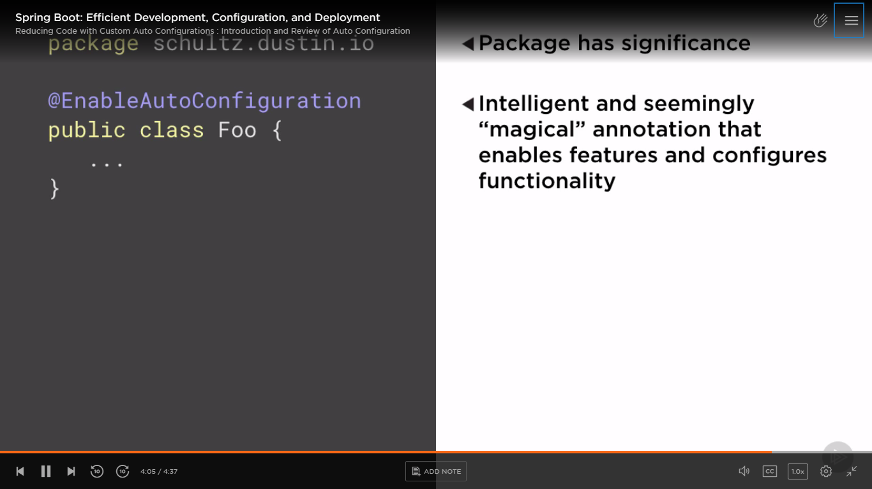

Package (where code is kept) is important because it acts as base for auto configurations.

To remove the below 3 boilerplate annotations - @SpringBootApplication was introduced.

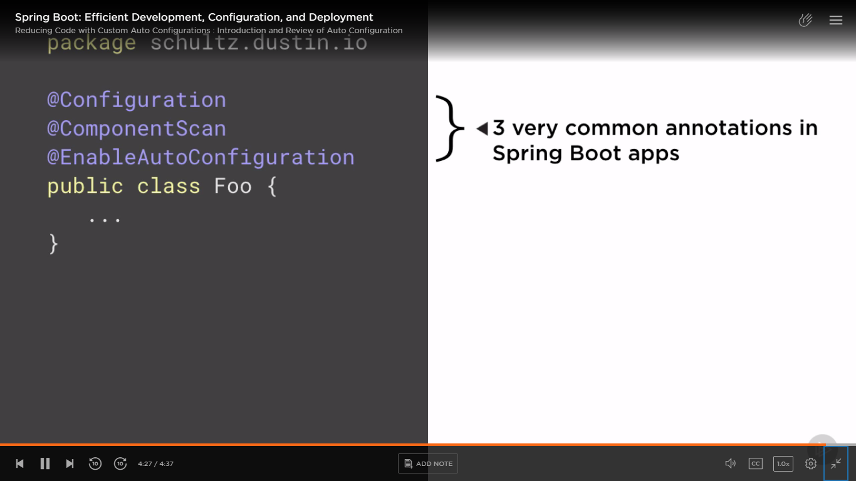

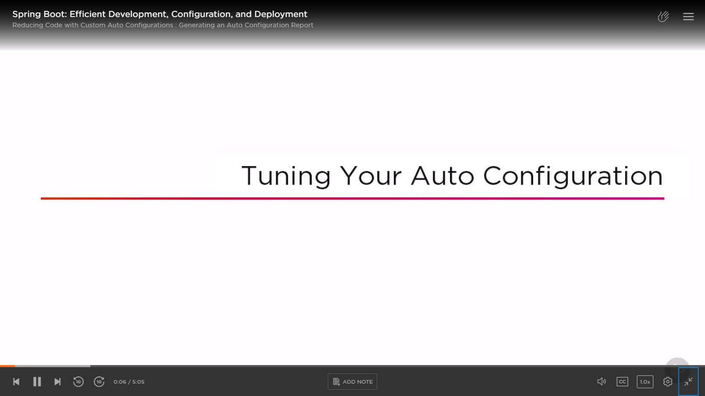

SB decides on auto configuration based on below 3 factors (bare minimum) -

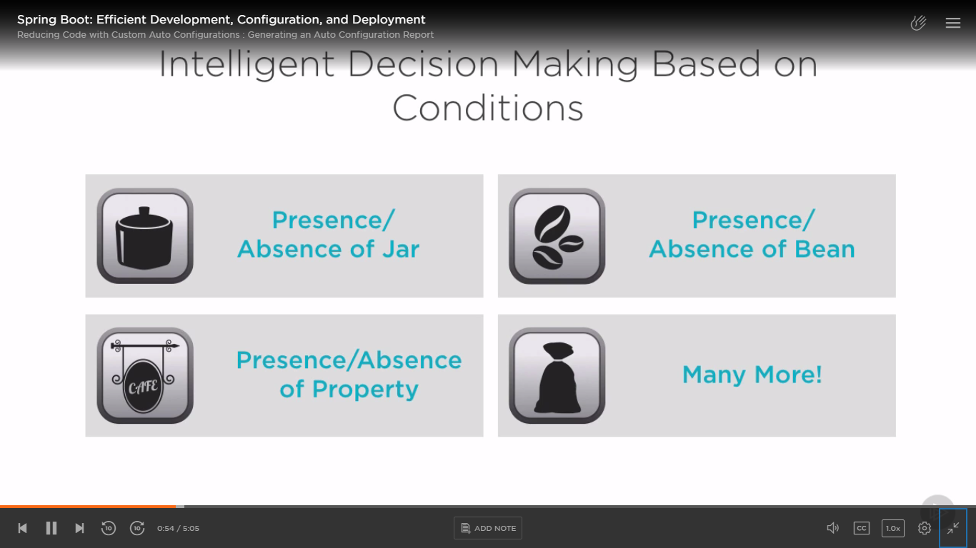

Auto Configuration Report –

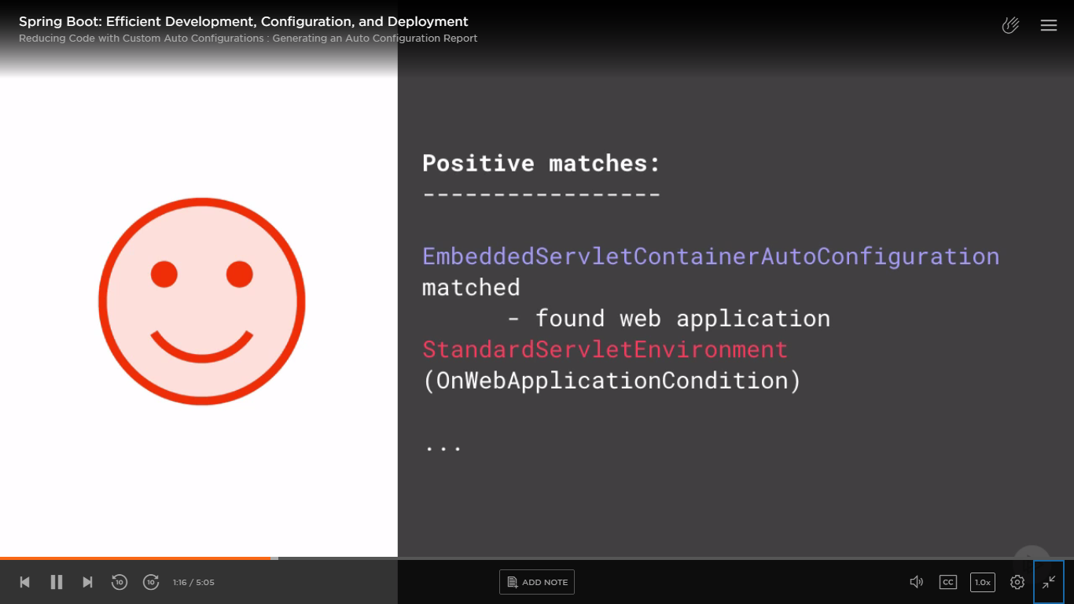

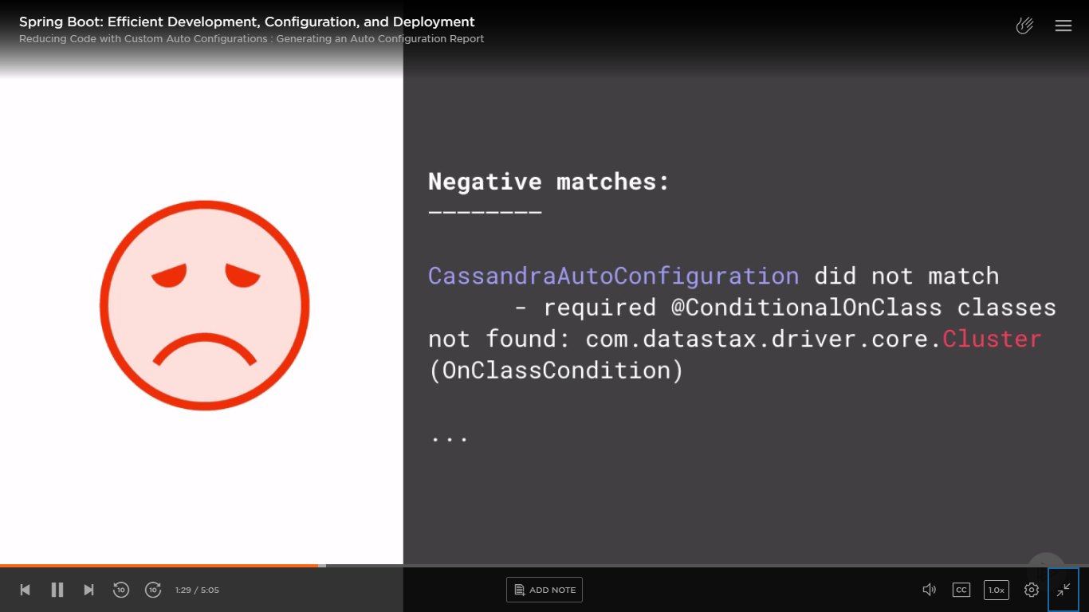

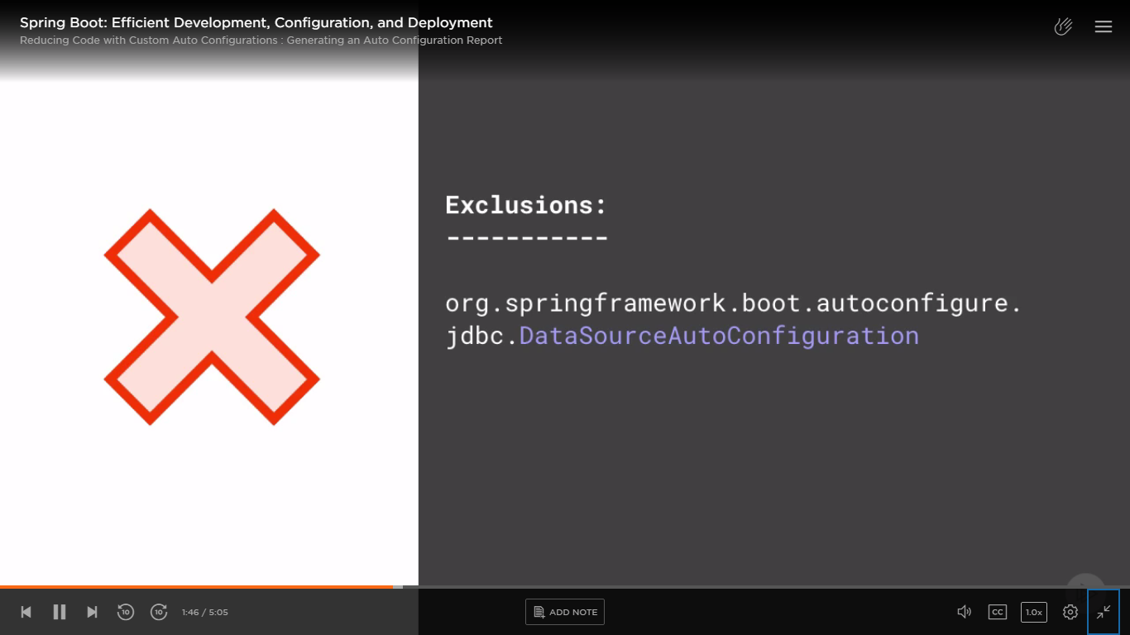

Always configured –

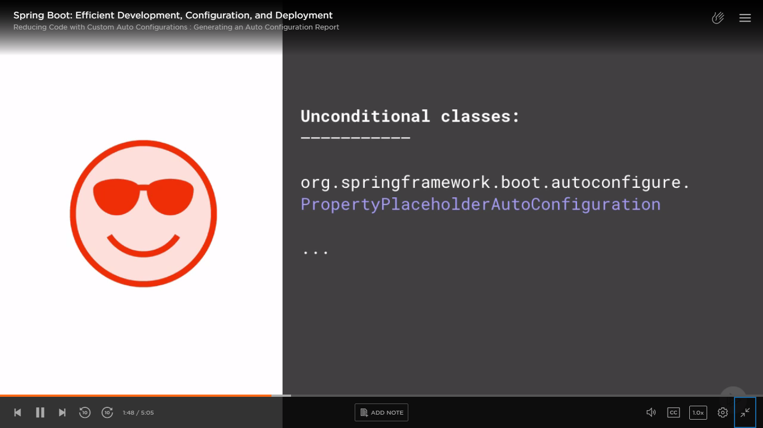

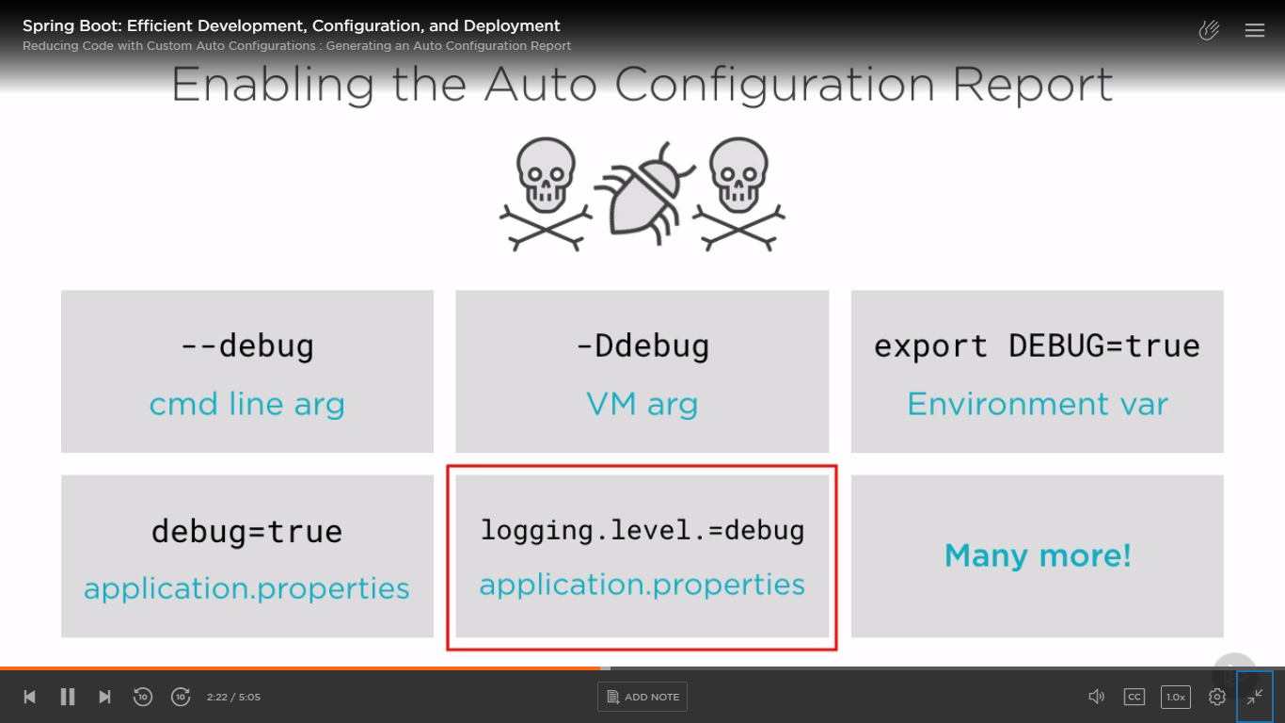

To enable auto configuration report in IntelliJ – We can do so in run Configurations – by checking Enable debug report -

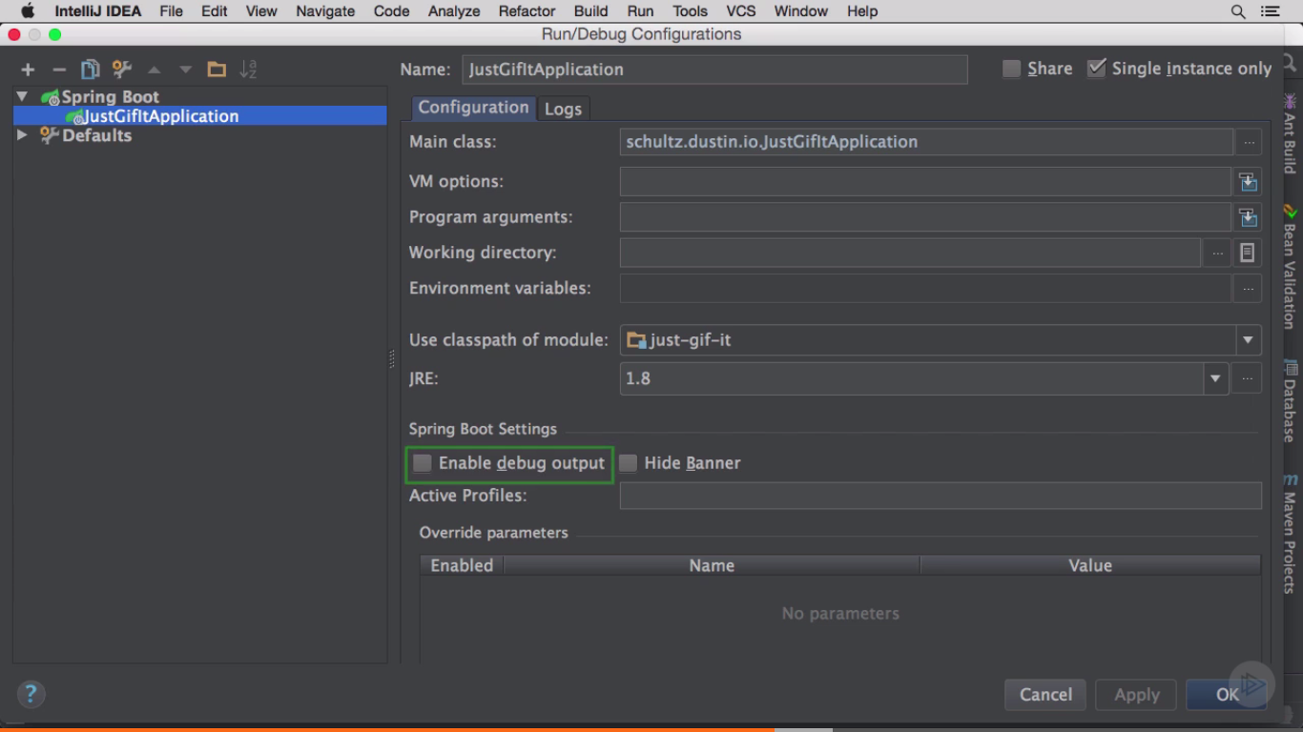

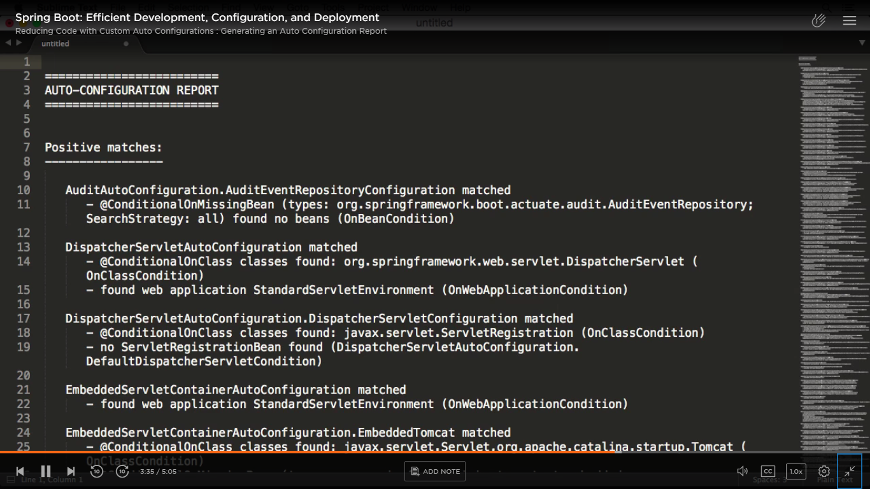

For example -

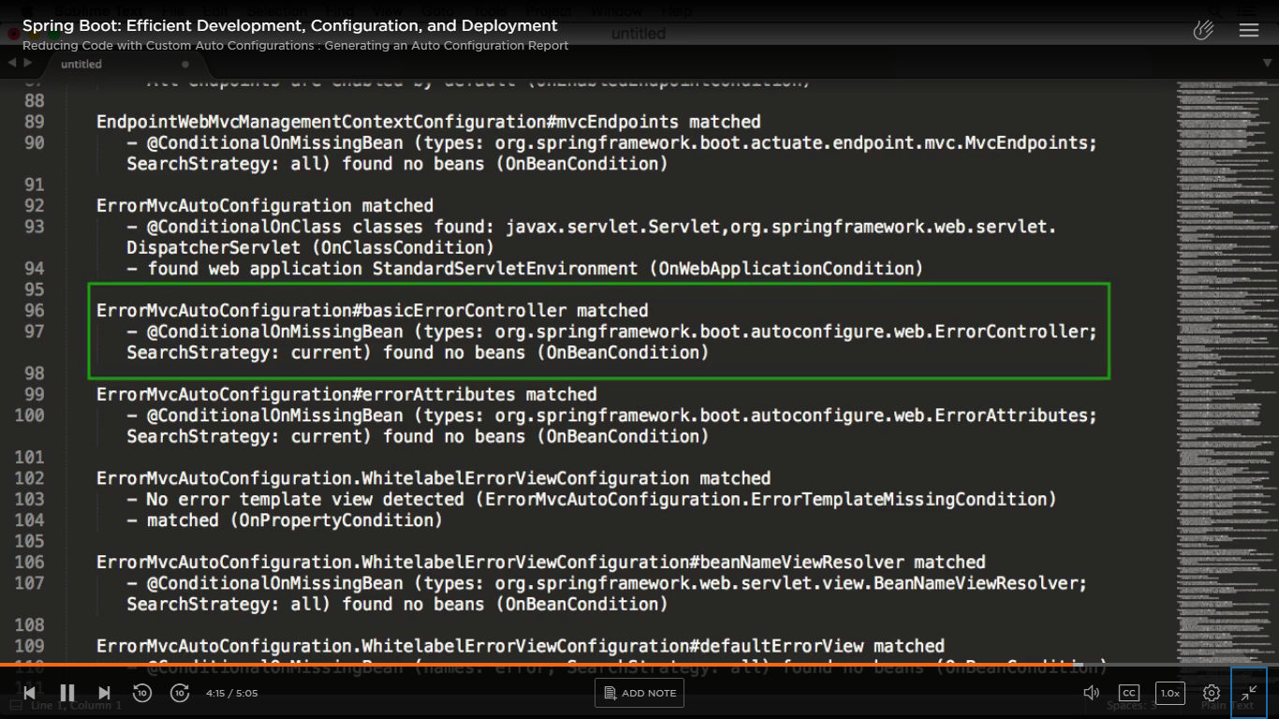

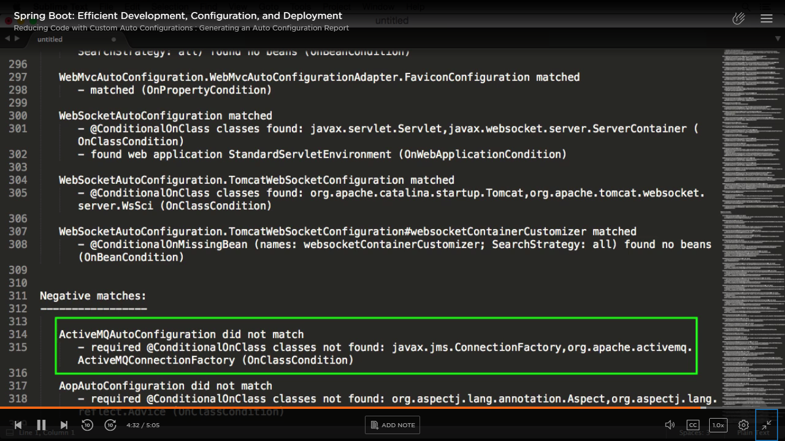

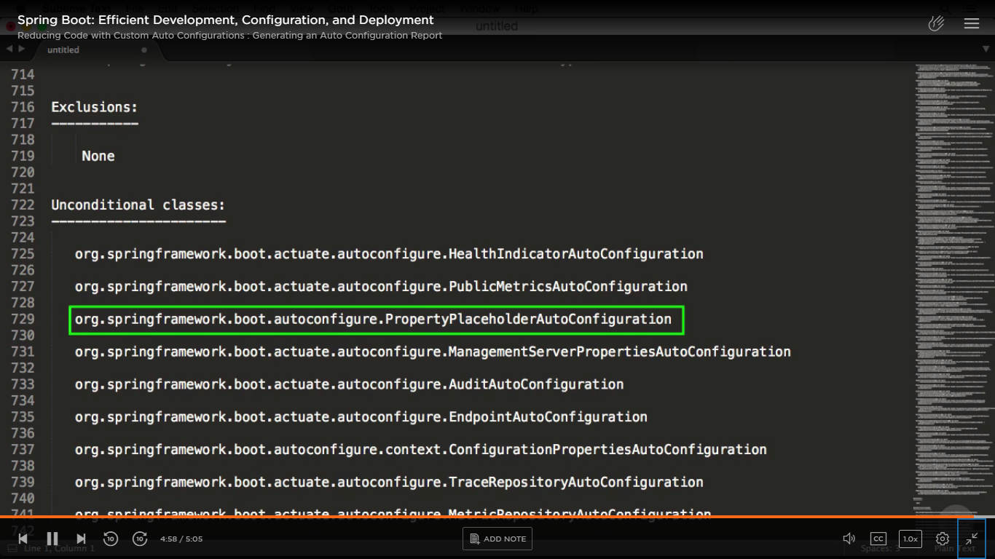

Excluding auto configurations – with “exclude” attribute/ param/ keyword

If you don’t exclude it, then also app runs fine. But to fine-tune app performance and reduce start up time – we should do it.

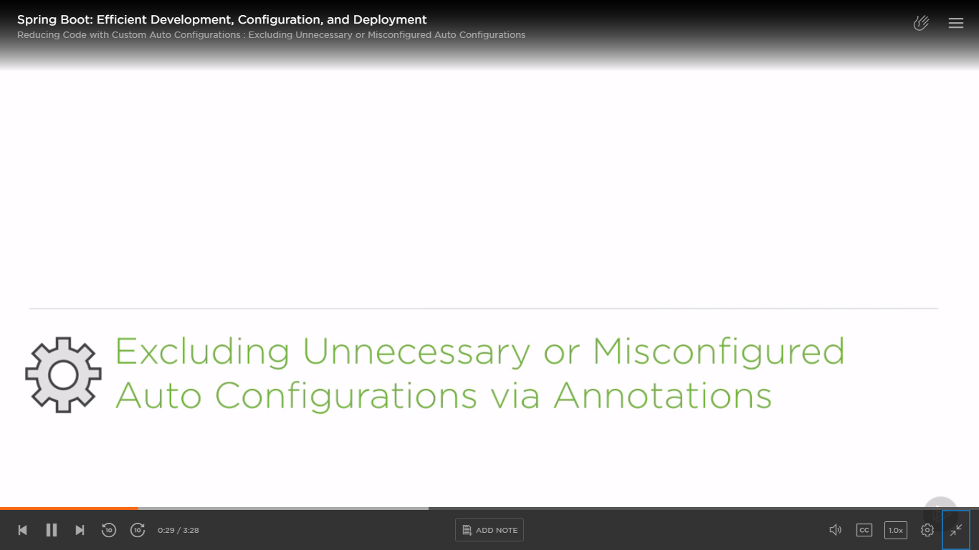

Can be used with both @EnableAutoConfiguration or @SpringBootApplication -

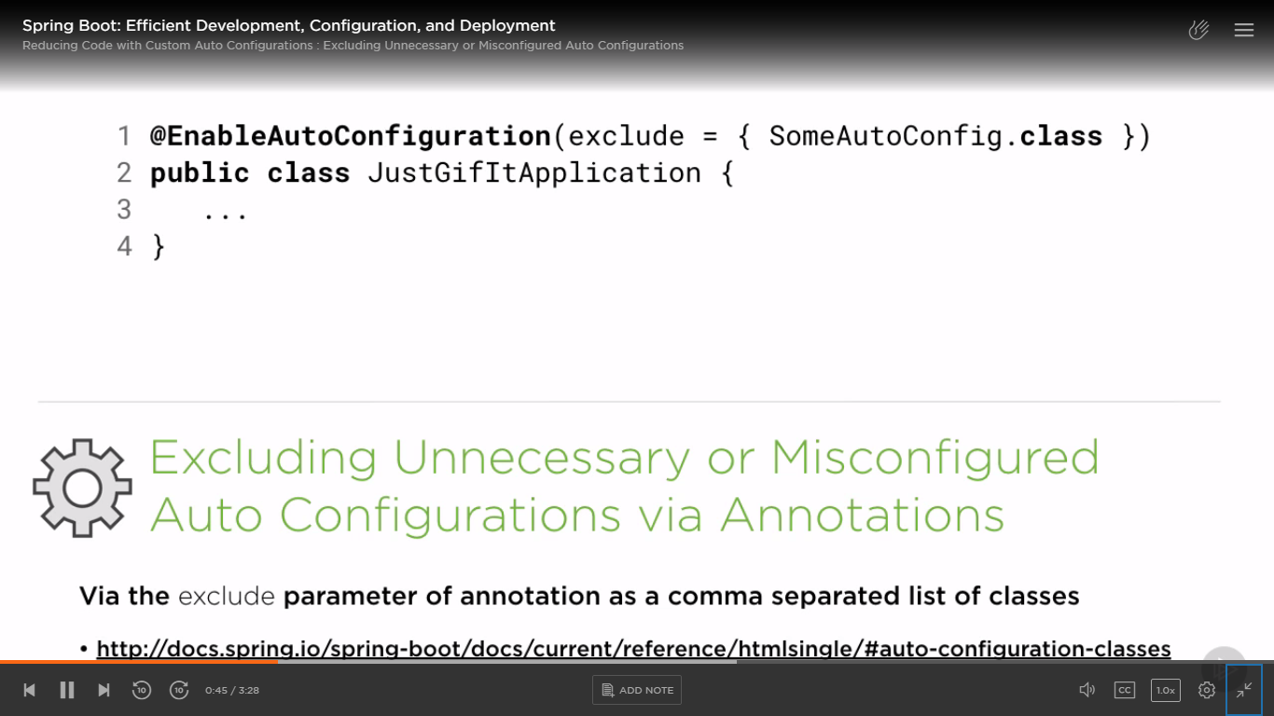

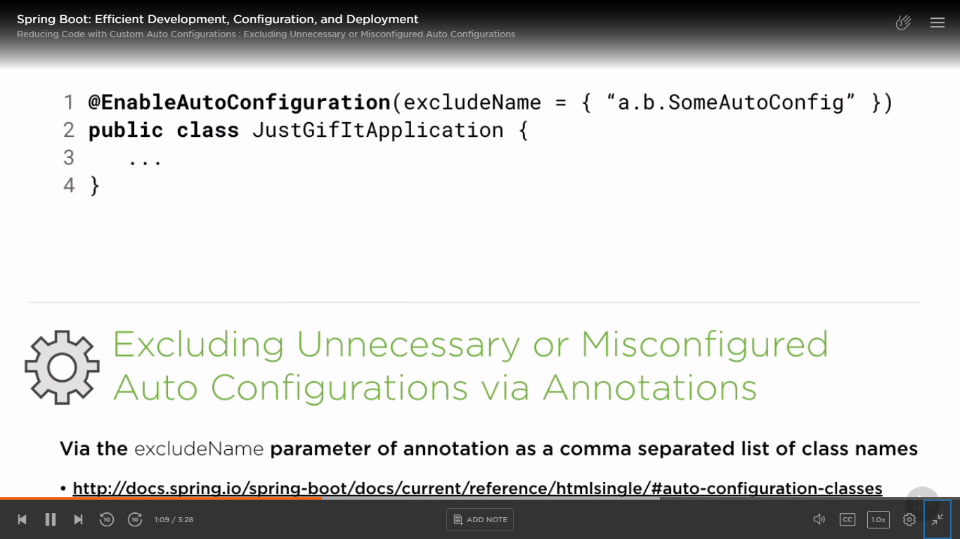

Can be used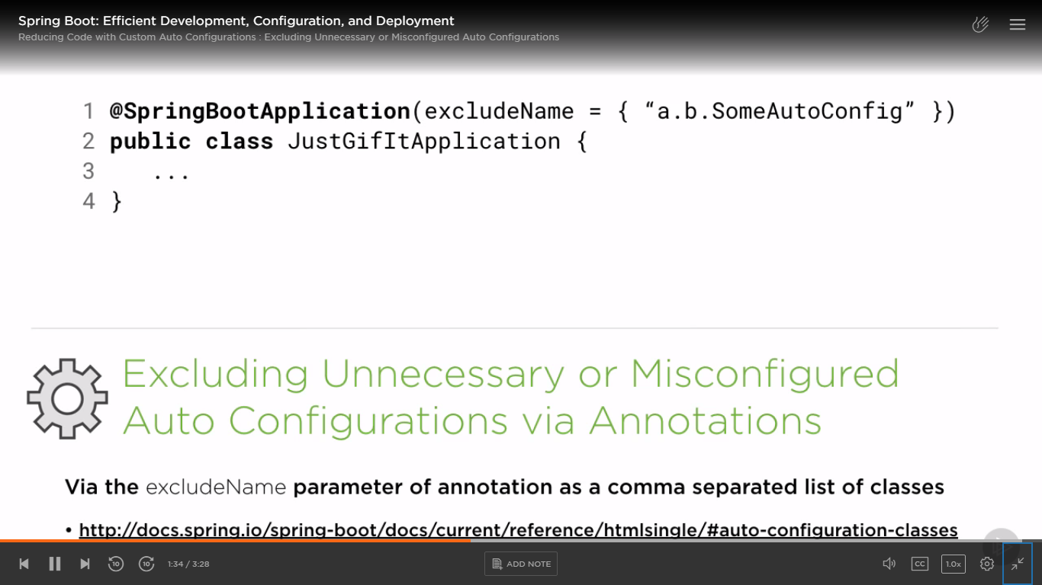

Auto config classes from spring Javadoc -

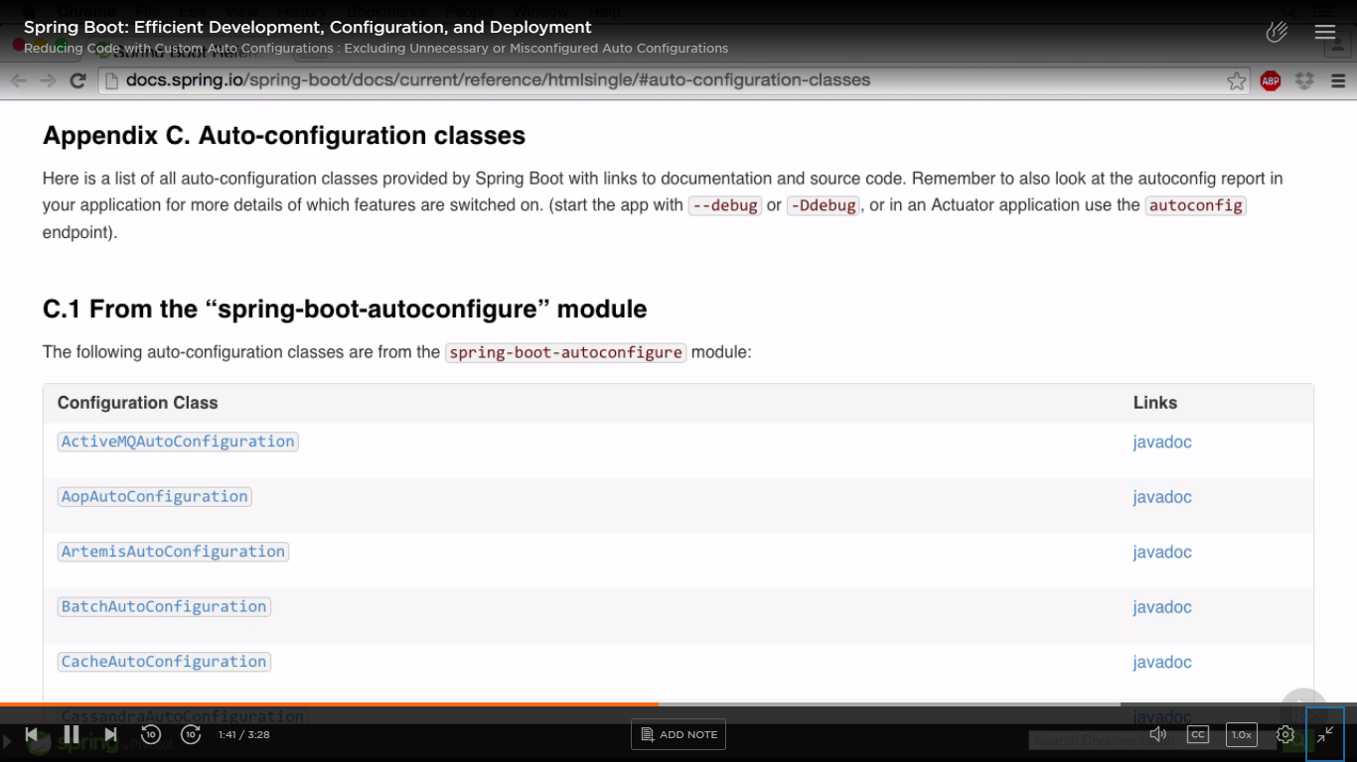

We can also exclude with property file – property name (key) has to be as mentioned below -

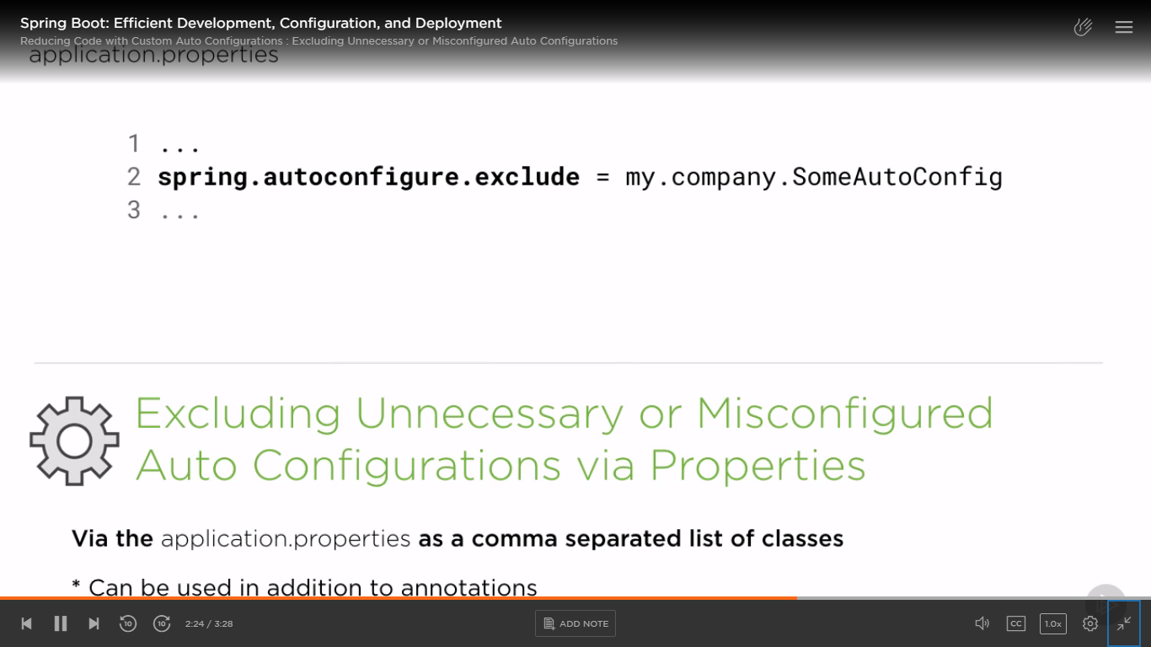

We can use both annotation and/ or using property.

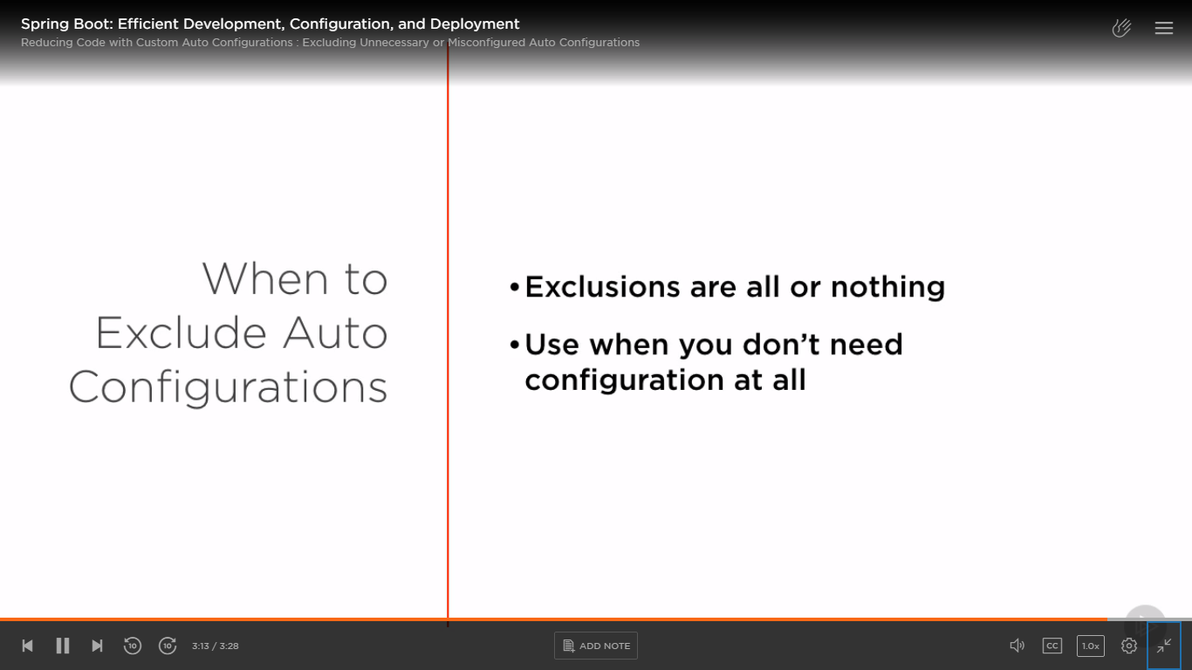

Reconfiguring auto configured properties -

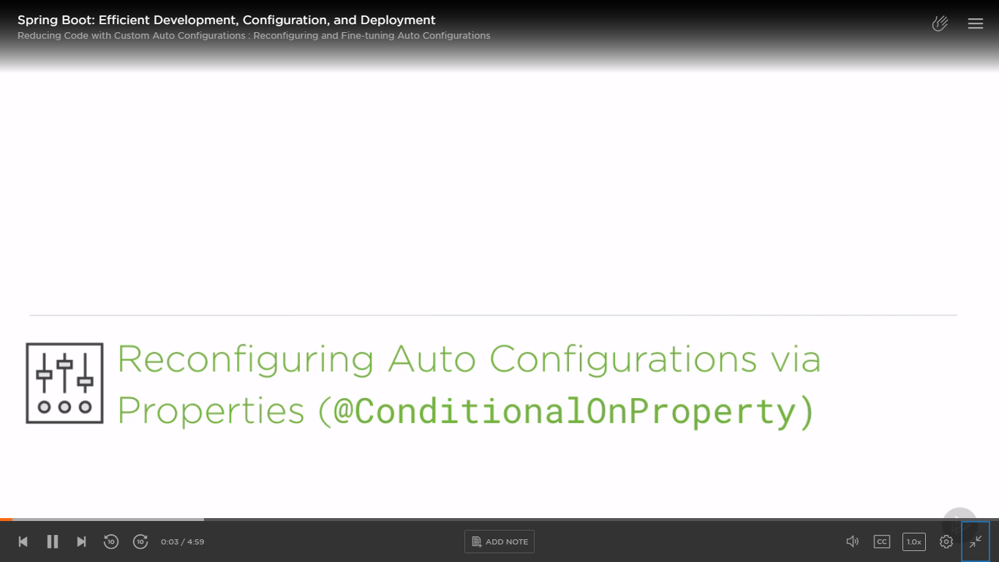

E.g.

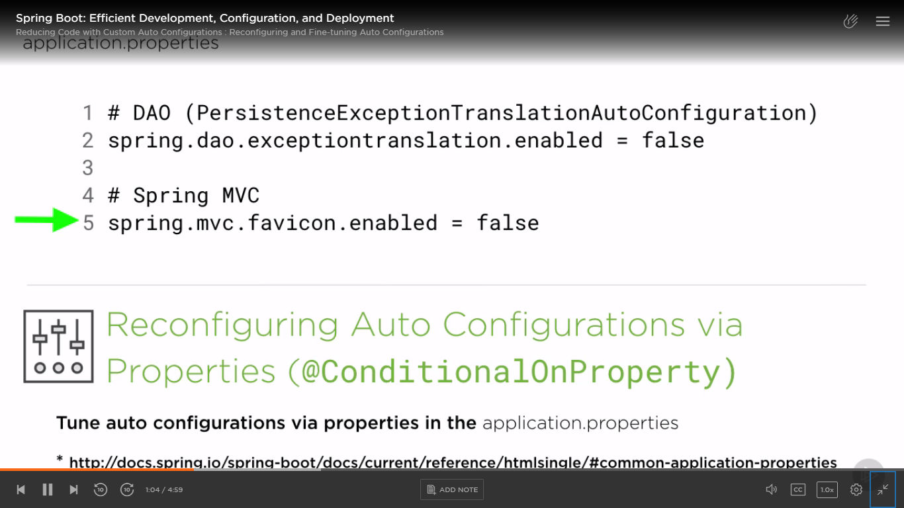

Common list of properties -

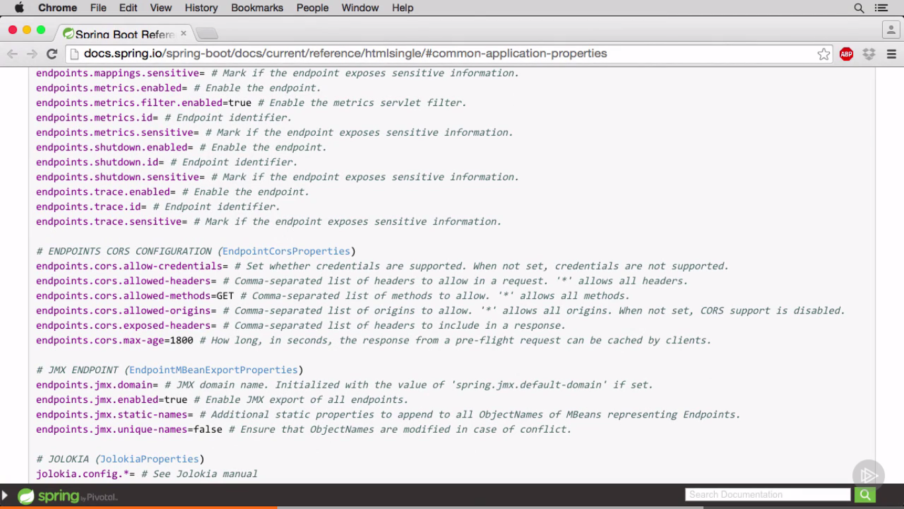

Another way for excluding/ overriding certain auto configured properties - Conditional on missing bean – auto configure something only if a bean/ bean type is missing –

SB Auto configuration works/ happens after our @Configuration marked classes have been read.

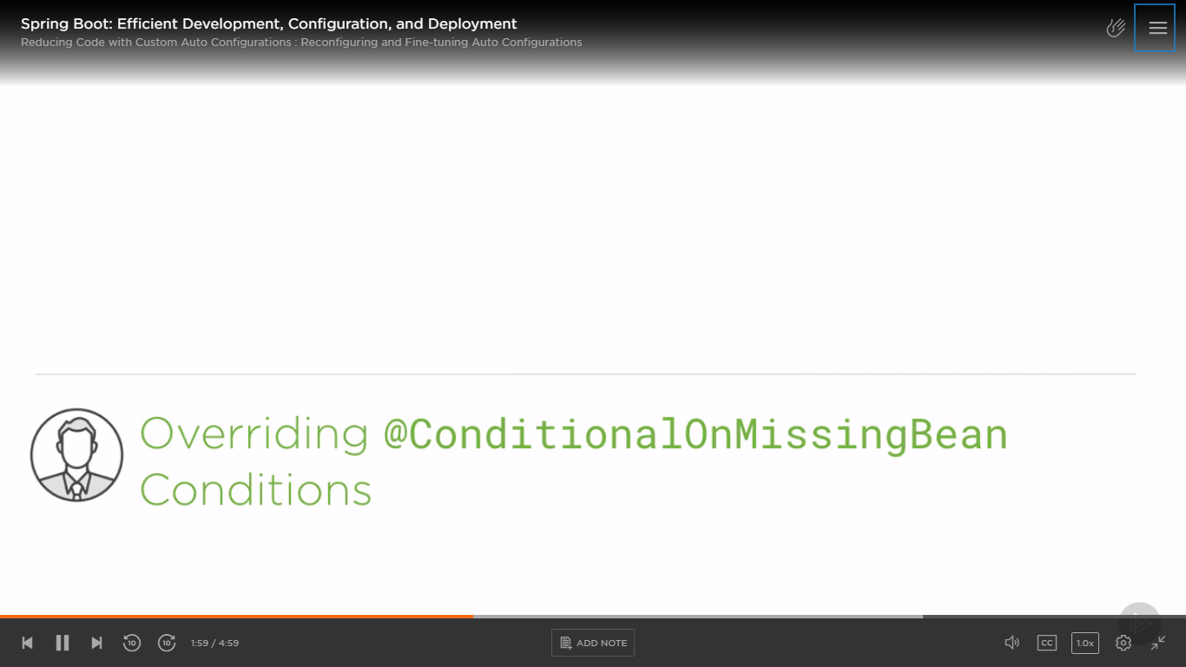

E.g. Below we have configured our own PropertySourcesPlaceholderConfigurer (which is a class that helps to read values via ${…} in either prop files or in java files with @Value annotation).

Here we are defining it to treat an empty string to null value while resolving the place holders.

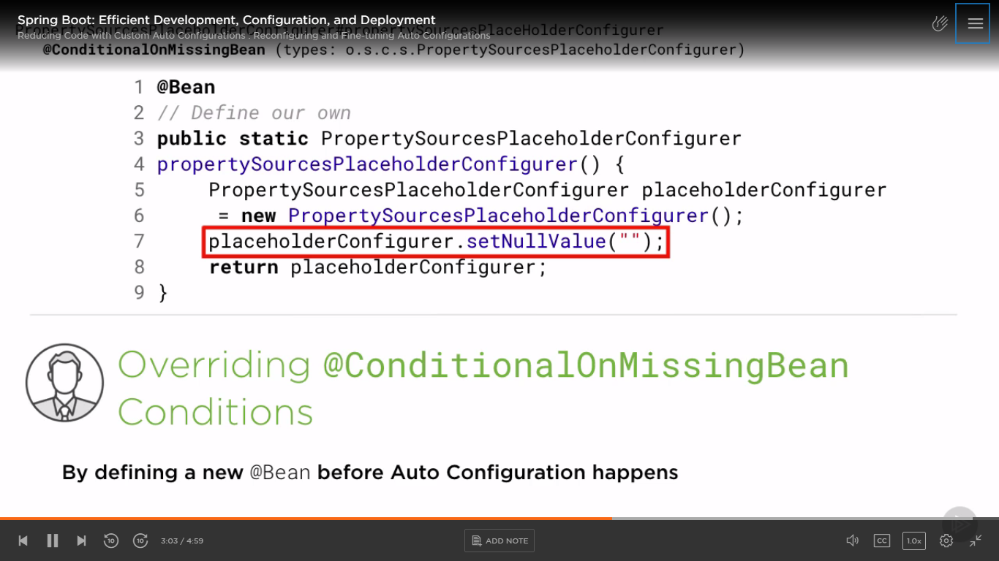

Excluding auto configured servlets or filters -

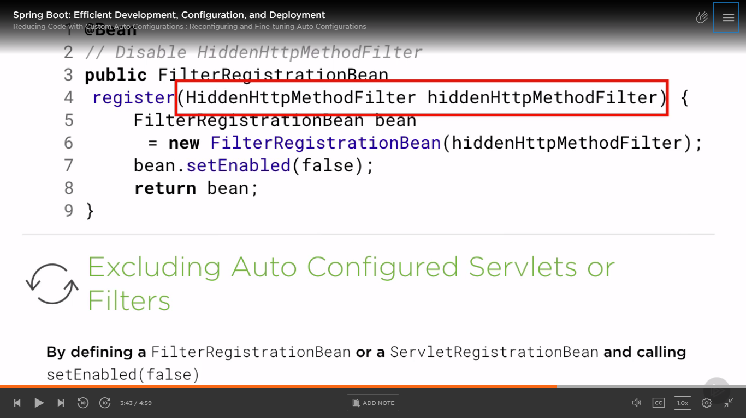

Our method accepts a parameter of the Filter/ Servlet type that we want to exclude from getting auto configured.

If none of the above methods work – manually configure required configuration classes and remove @EnableAutoConfiguration -

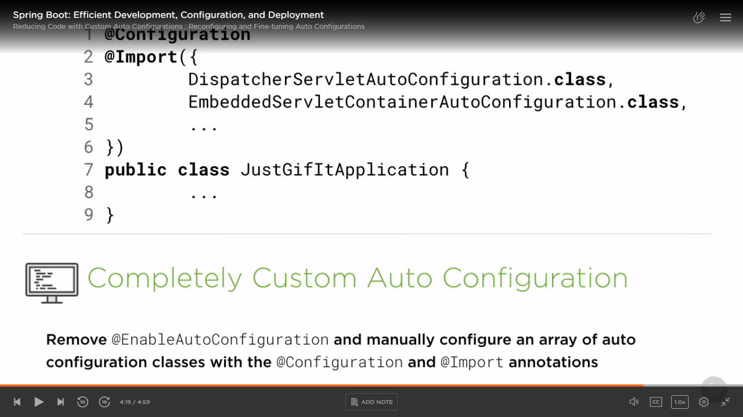

Don’t use this method unless you exactly know what you need and what is not needed from sensible defaults/ auto configurations provide by default by SB.

Excluding non-required classes and filters – do it only when you fairly know that you won’t need those dependencies and for fine tuning -

Through exclude ({array_of_classes}) at class level -

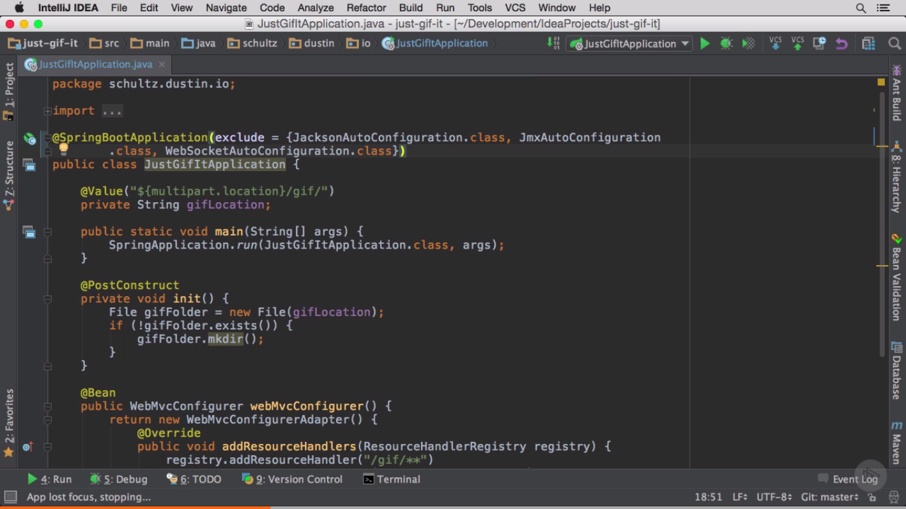

De-registering non-required filters -

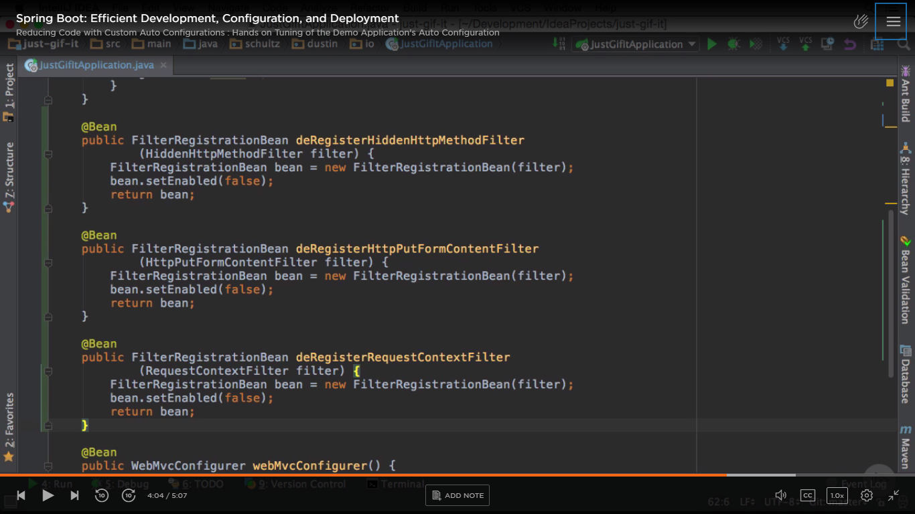

Through property file -

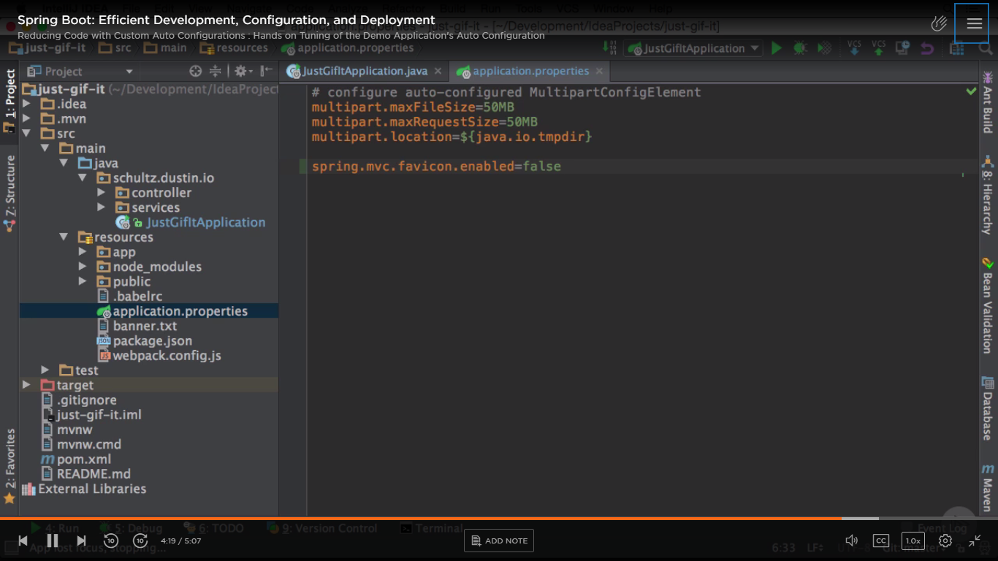

Restart app – you can see in logs – certain things disabled -

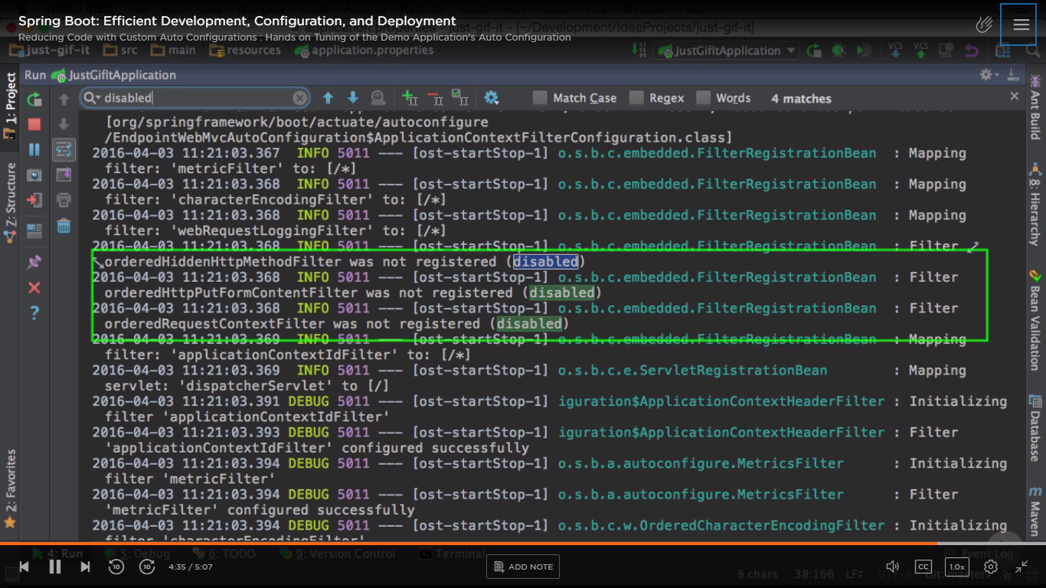

Excluded classes –

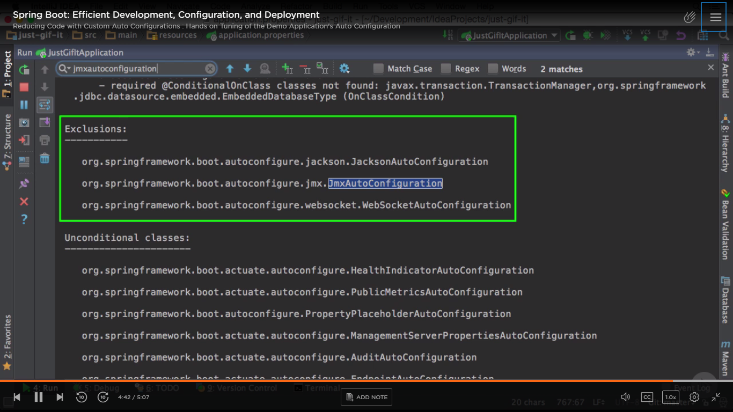

Writing our own @Conditional configuration -

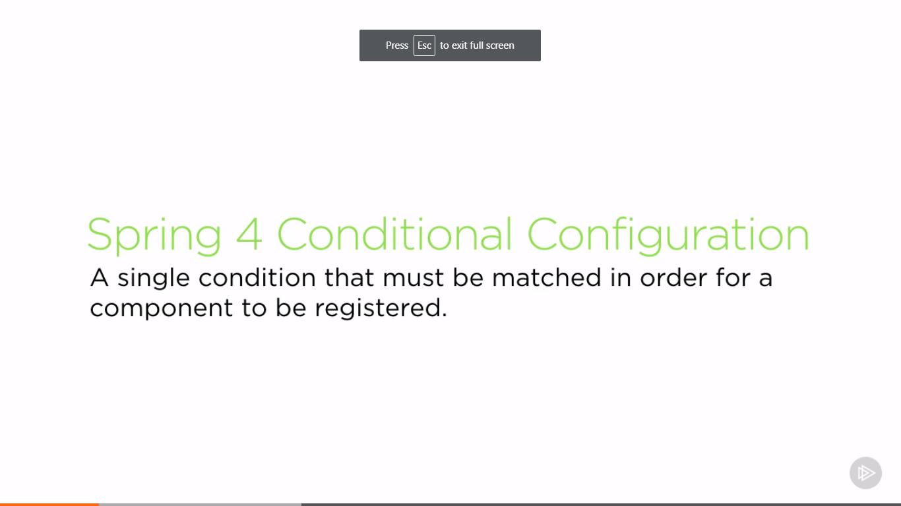

ConditionalOnClass – Apply a certain configuration only if the classes mentioned via an array are present on classpath. Either fully qualified class names or ClassName.class can be added to that array.

ConditionalOnMissingBean – Inverse of above

All of below takes array of strings or objects.

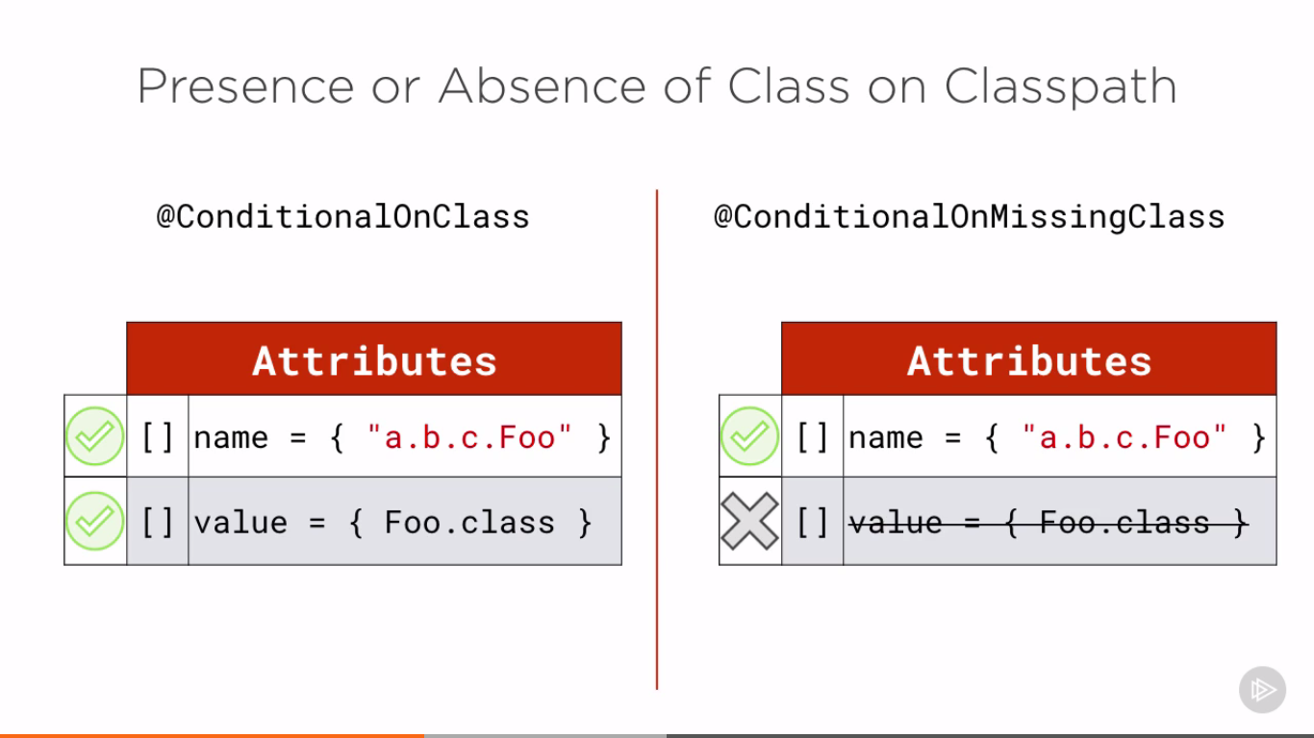

ConditionalOnBean and ConditionalOnMissingBean -

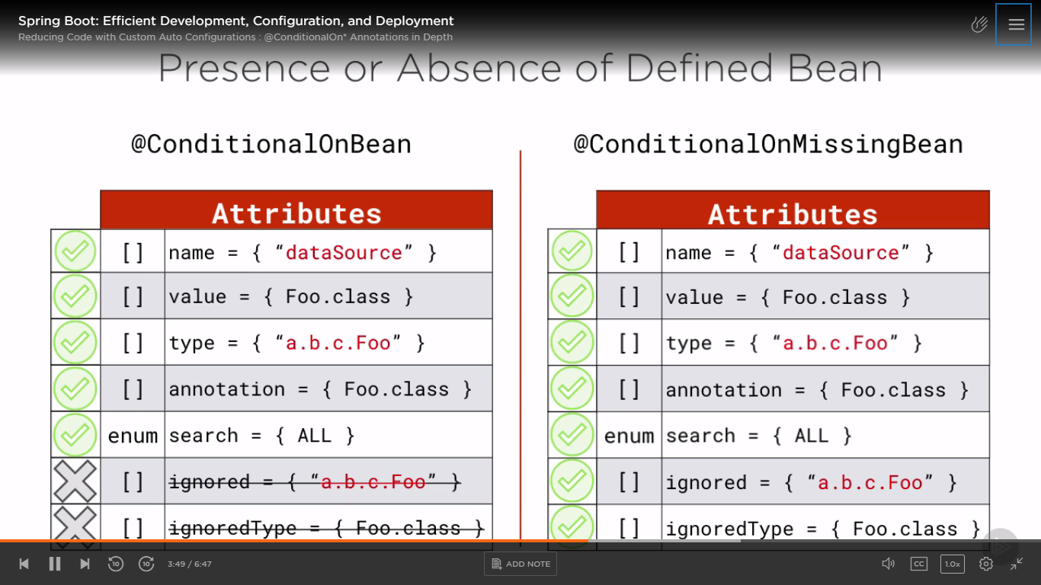

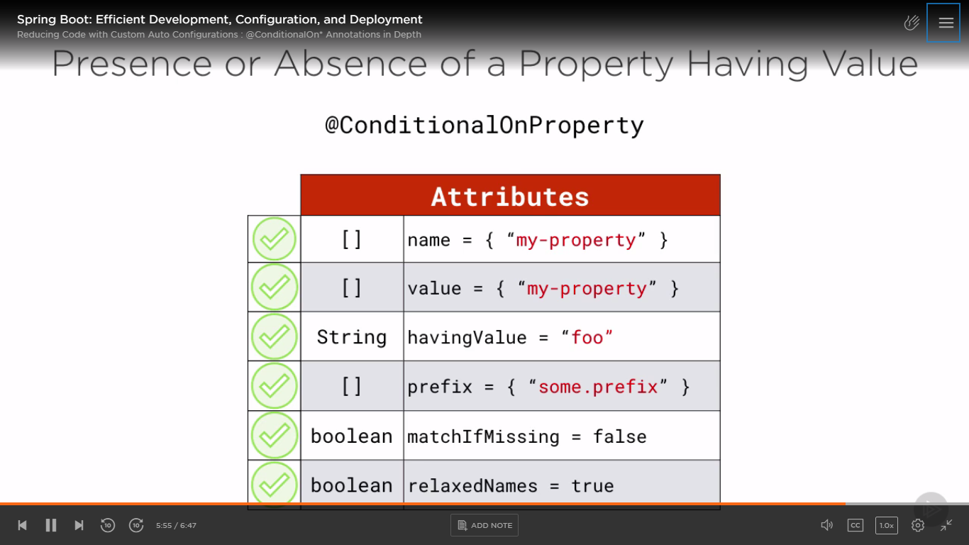

Additional conditions -

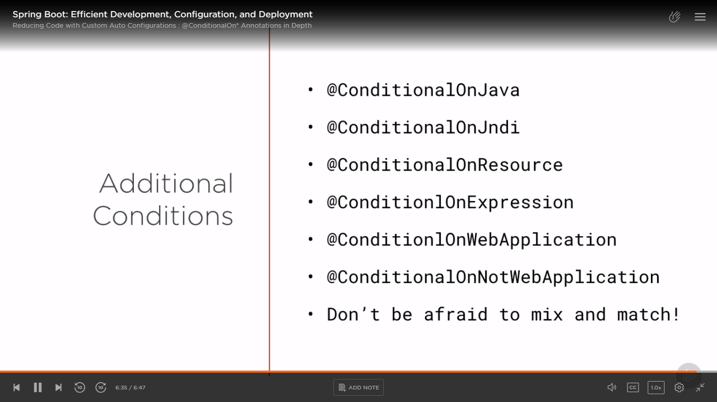

Writing our own first auto configuration -

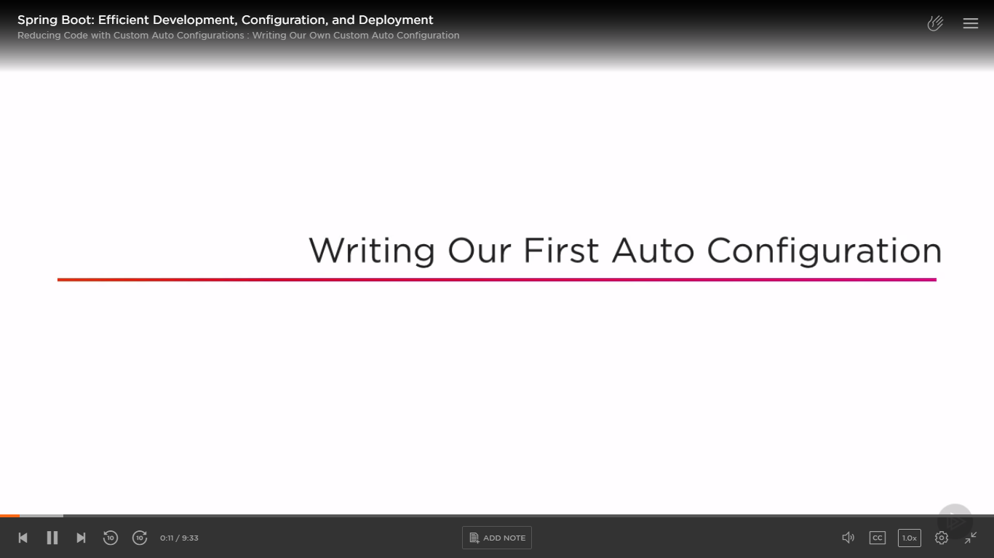

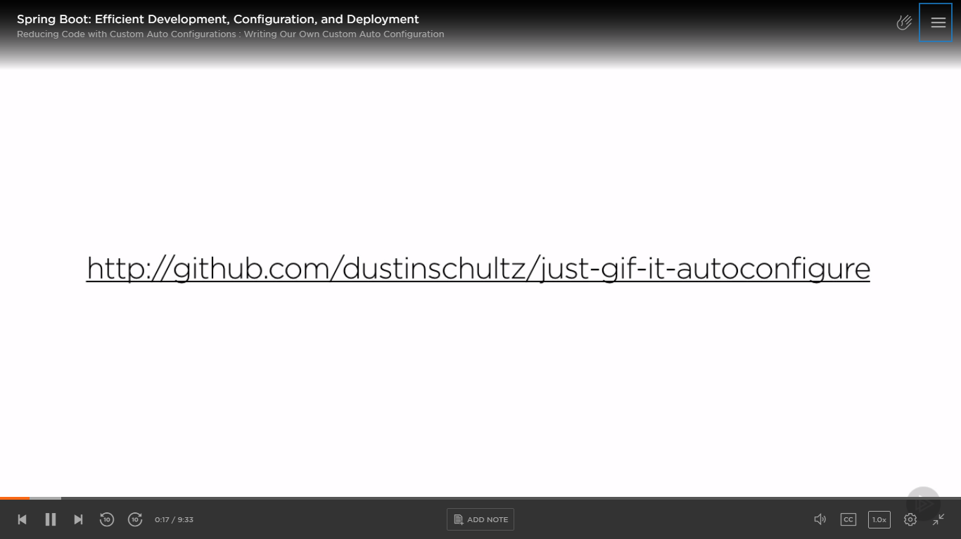

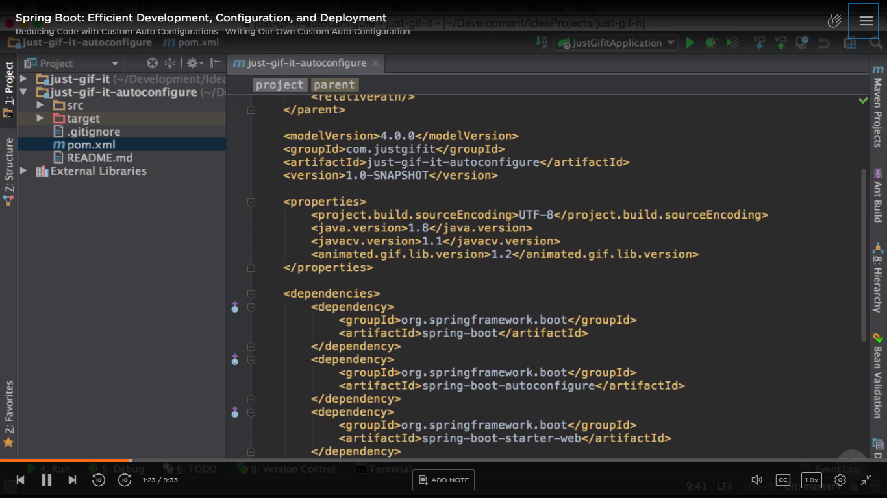

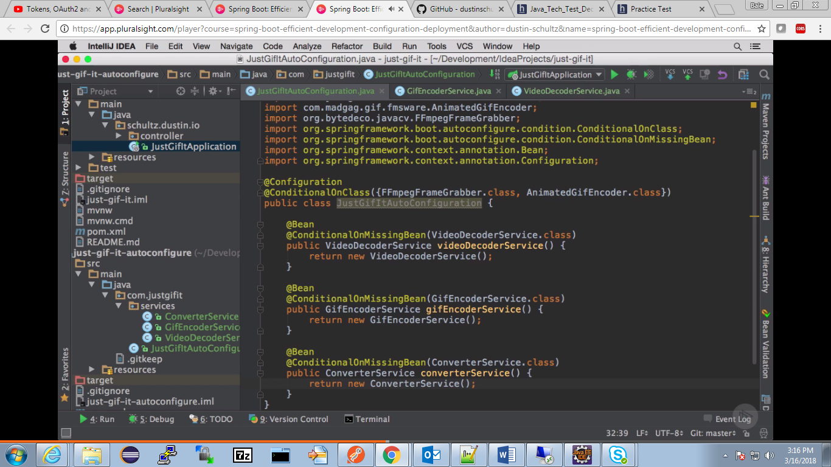

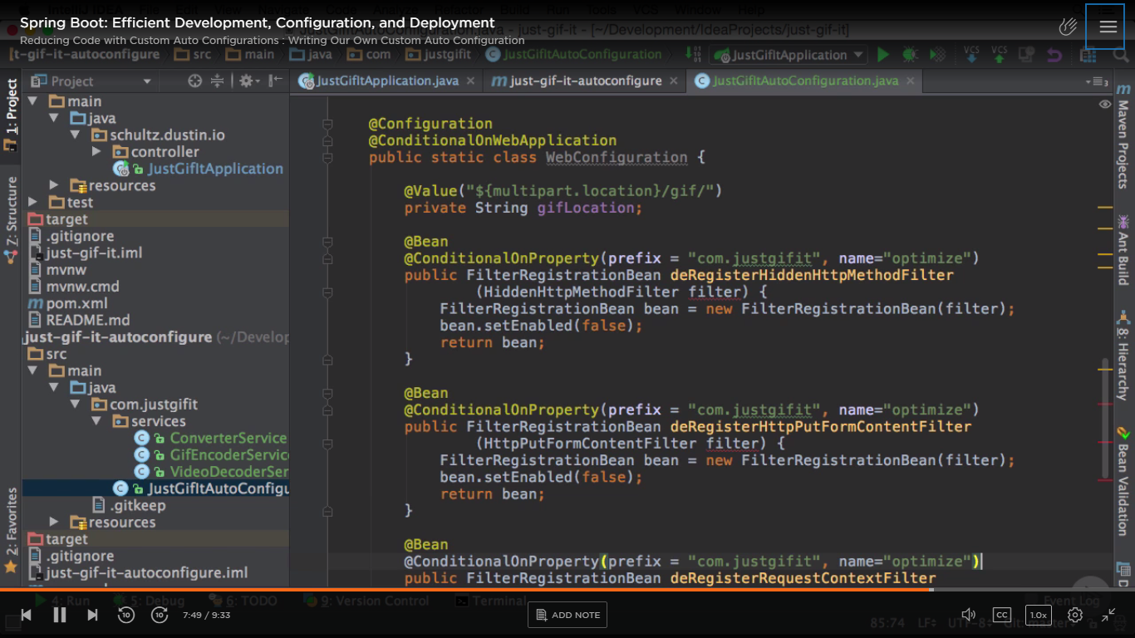

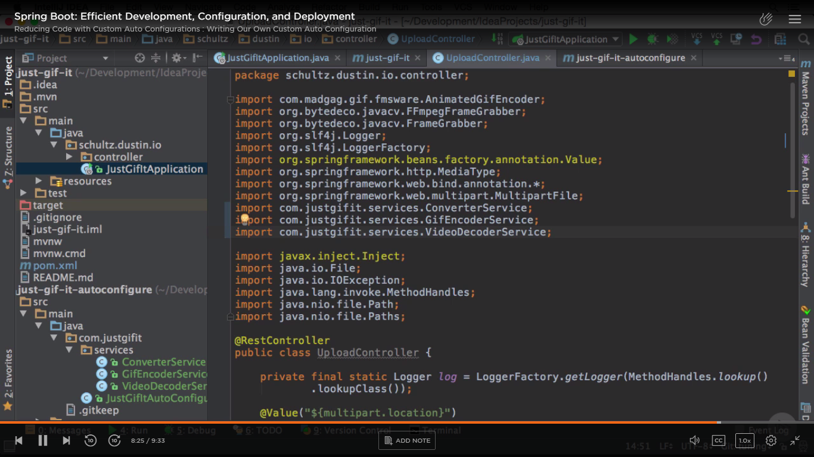

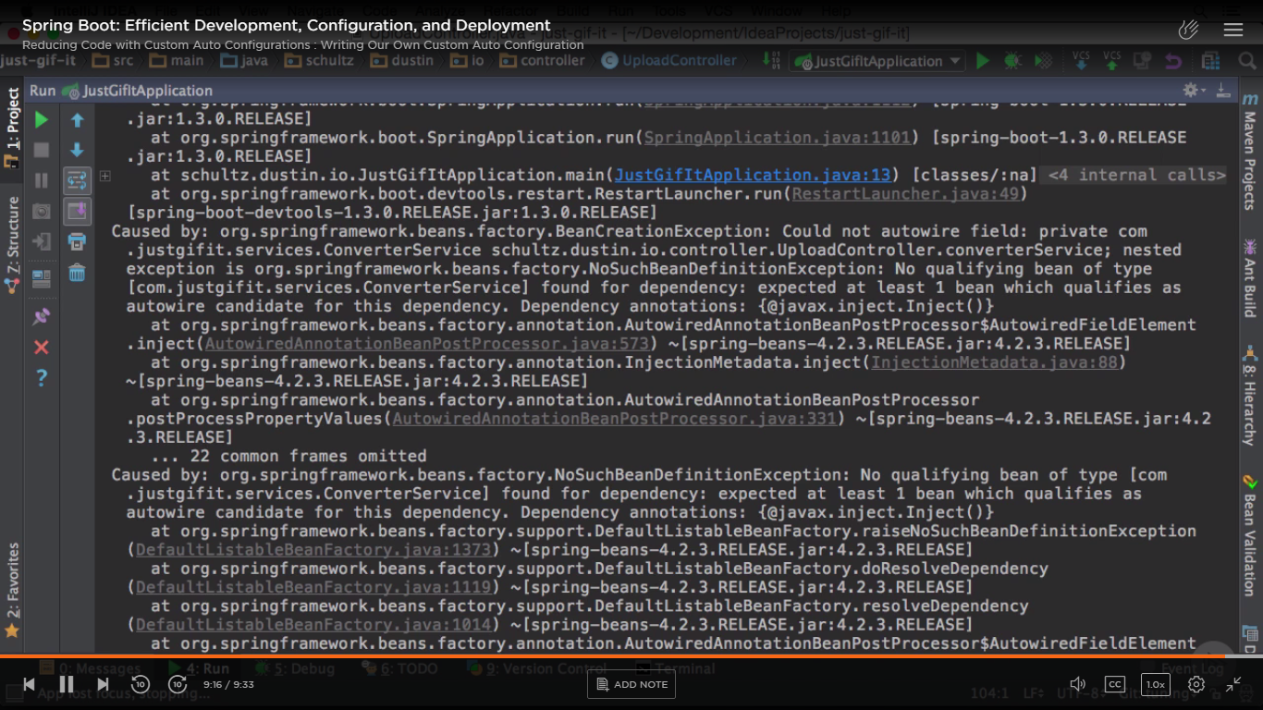

Working of auto configuration -

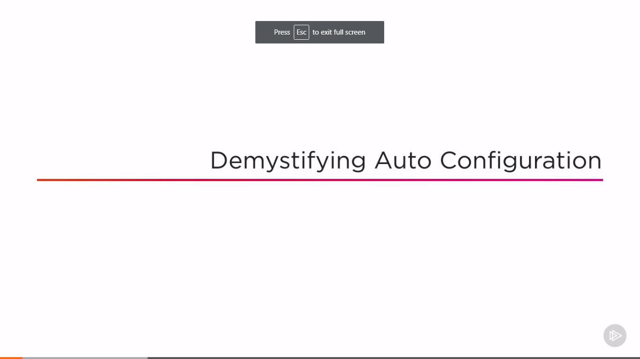

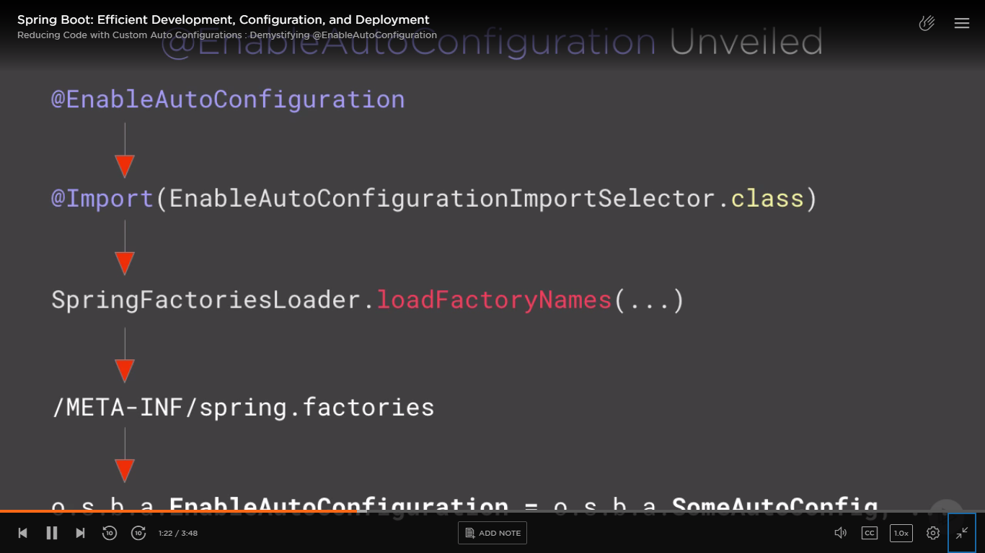

spring.factories is like property file containing key-value pairs. It is loaded by loadFactoryNames()

To enable your custom auto configuration (which thrown exception in above step), we need to create our own META-INf/spring.factories

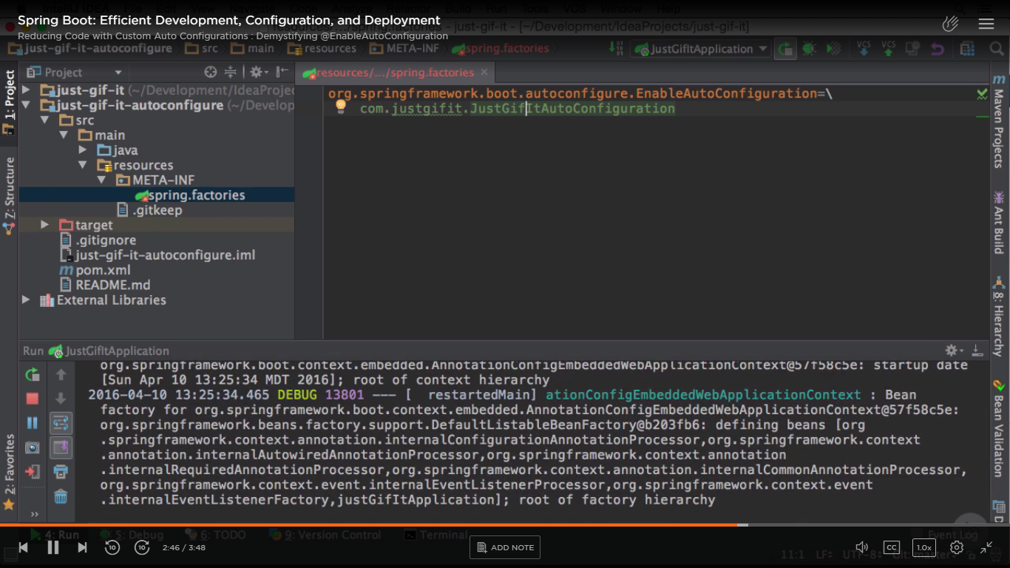

When you run app now – it runs successfully- in logs see auto config matched and enabled -

